ARROW FUNCTIONS

# Program 1: Sum of all numbers in an array…

*let* numbers=(*value*)*=>*{

*let* sum =0;

    for (*let* i=0;i<*value*.length;i++){

           sum=sum+*value*[i]

    }

    console.log(sum)

    }

    numbers([11,22,33,44,55])

# Result:

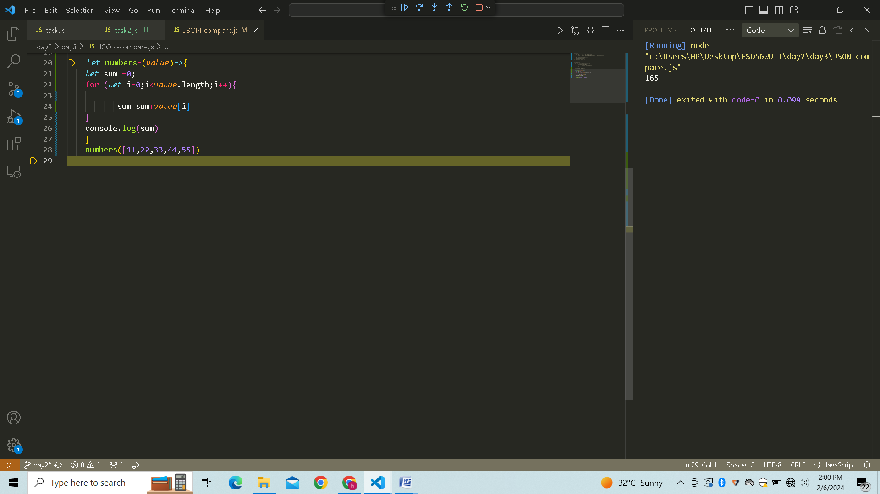

# Program 2: Print odd numbers in an array…

*let* odd=(*value*)*=>*{

  for (*let* i=0;i<*value*.length;i++){

          if(*value*[i]%2!=0){

                  console.log(*value*[i])

          }

  }

  }

  odd([11,22,33,44,55])

# Result:

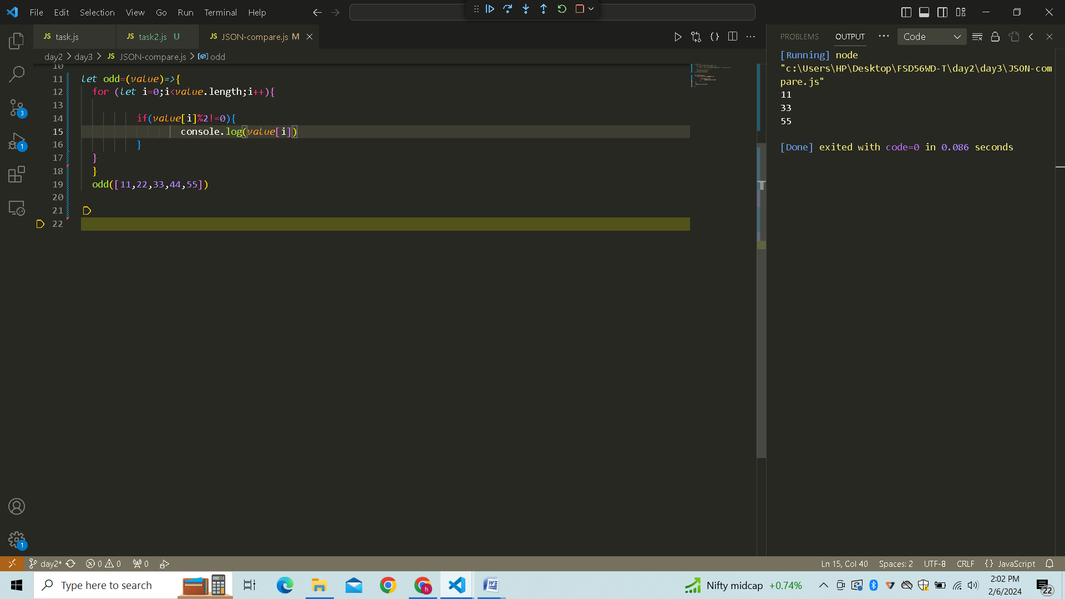

# Program 3: Convert all the strings to title caps in a string array…

*let* titleCaps=(*str*)*=>* {

*str* = *str*.toLowerCase().split(' ');

    for (*let* i = 0; i < *str*.length; i++) {

*str*[i] = *str*[i].charAt(0).toUpperCase() + *str*[i].slice(1);

    }

*let* result= *str*.join(' ');

    console.log(result);

}

titleCaps("MY NAME IS HARISH")

# Result:

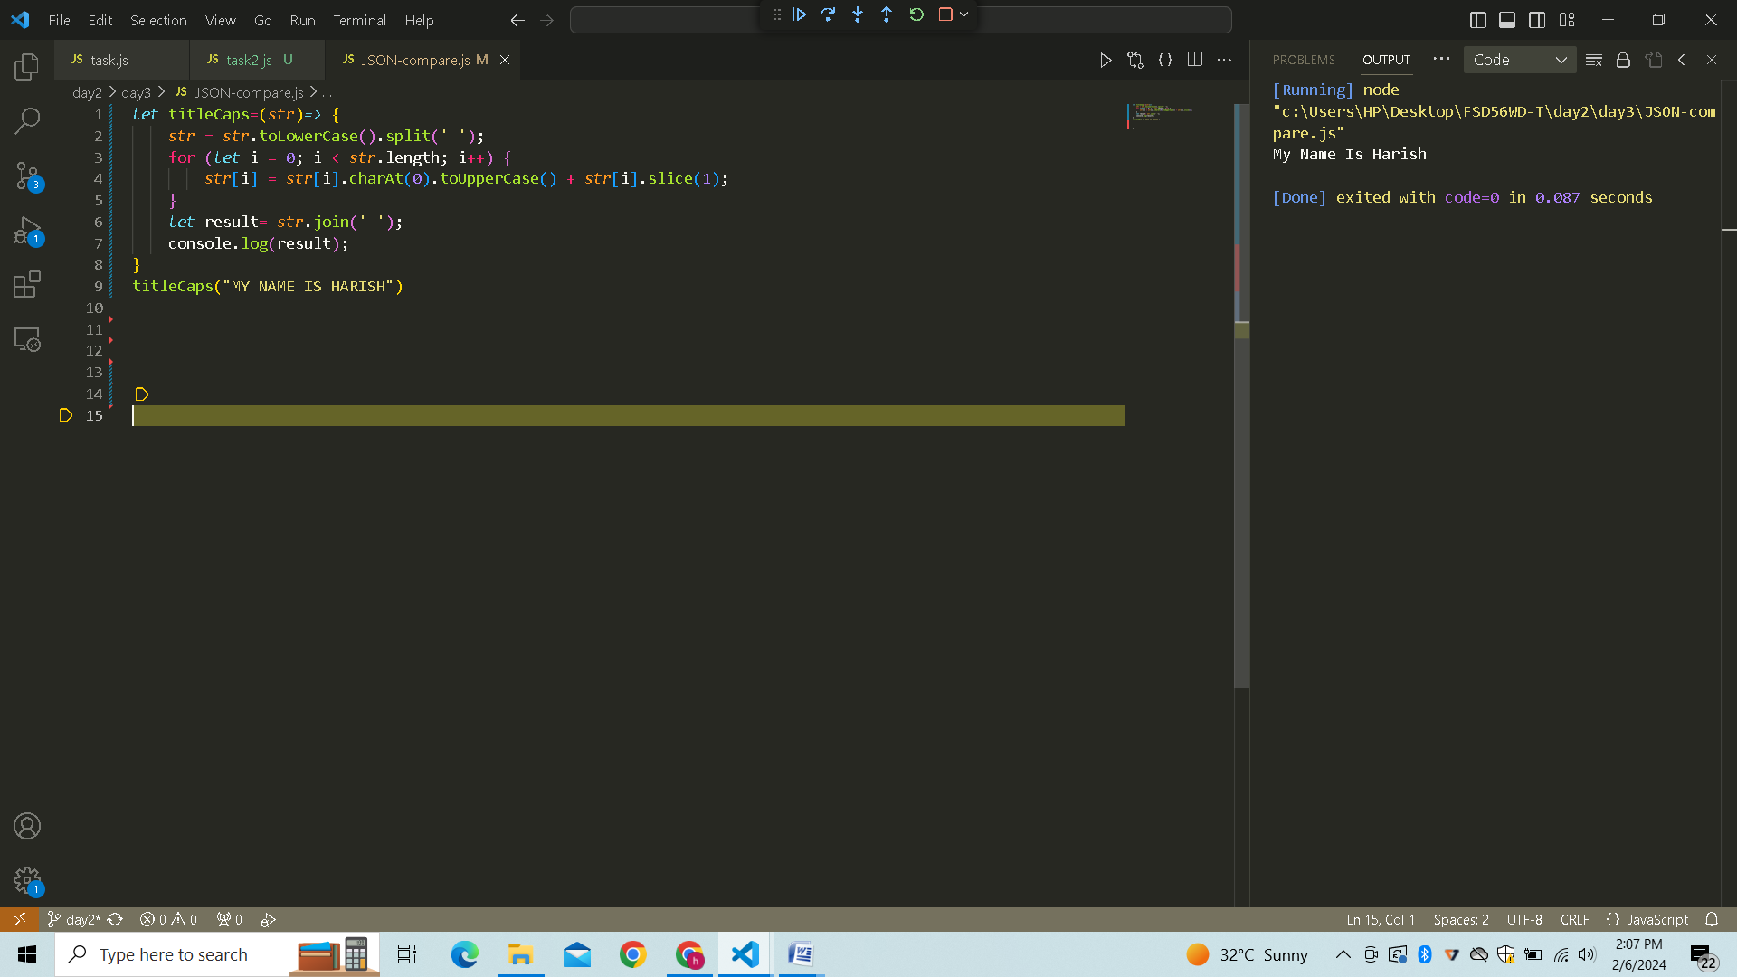

# Program 4: Return all the prime numbers in an array…

*let* prime =(*numArray*)*=>*{

*numArray*=*numArray*.filter((*number*) *=>*{

        for (*let* i=2 ; i <=Math.sqrt(*number*); i++){

            if (*number* % i==0)

            return false;

        }

        return true;

    });

    console.log(*numArray*)

}

prime([1,2,3,4,5,6,7,8,9,10]);

# Result:

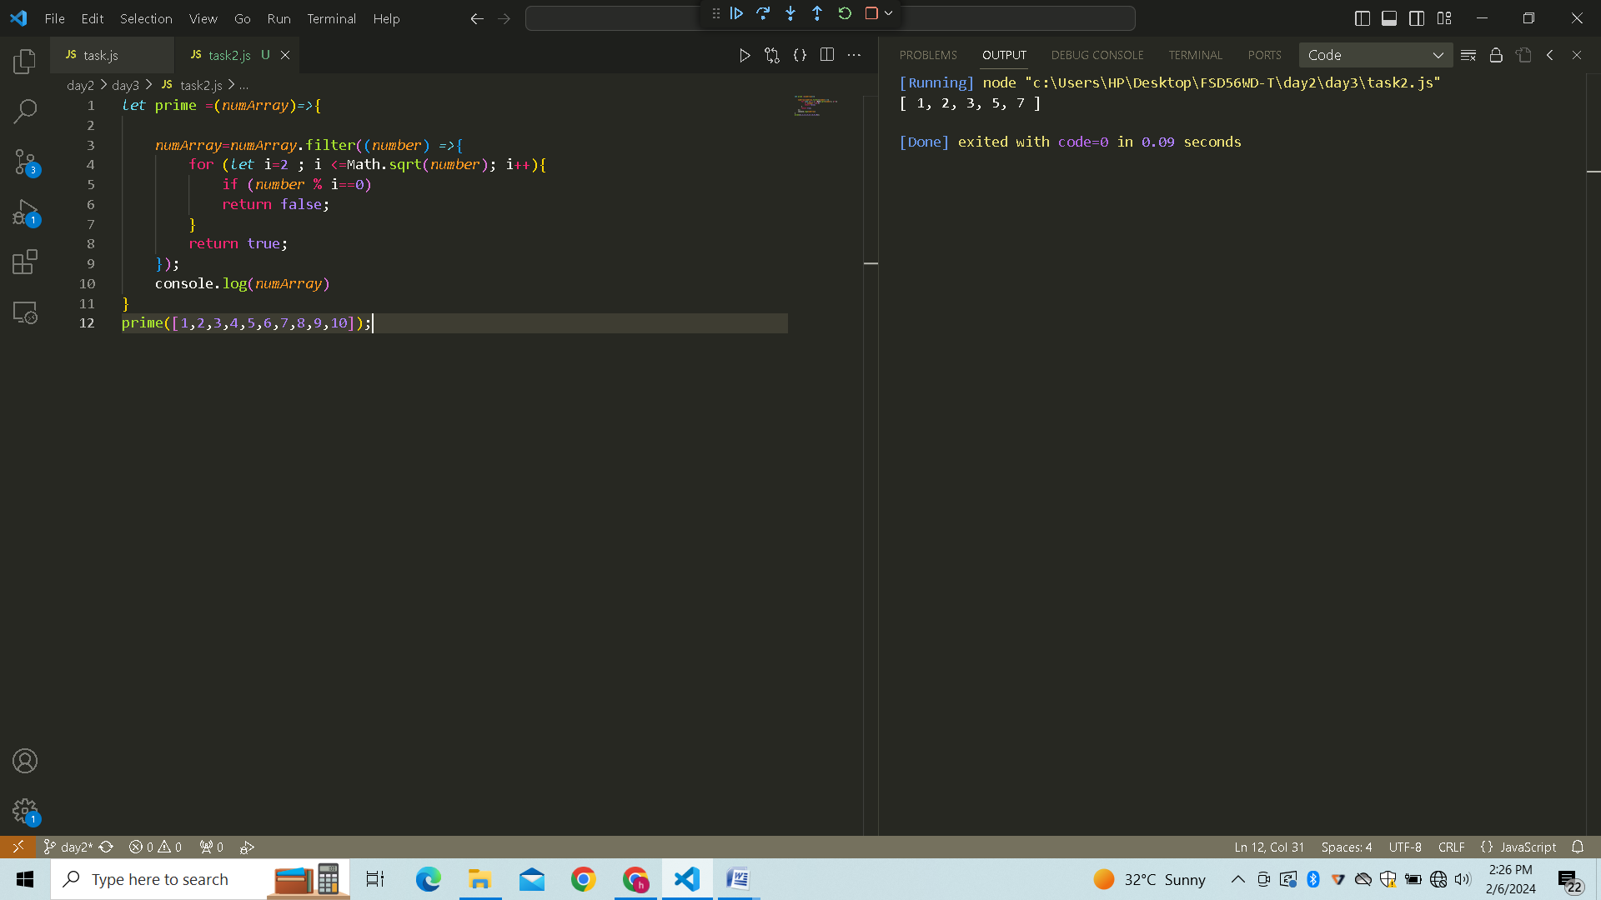

# Program 5: Remove the duplicate numbers in an array…

*let* duplicate =(*array*)*=>*{

*let* dup=[... new *Set*(*array*)];

    console.log(dup)

}

duplicate([1,1,2,3,3,4,4,5,6])

Result:

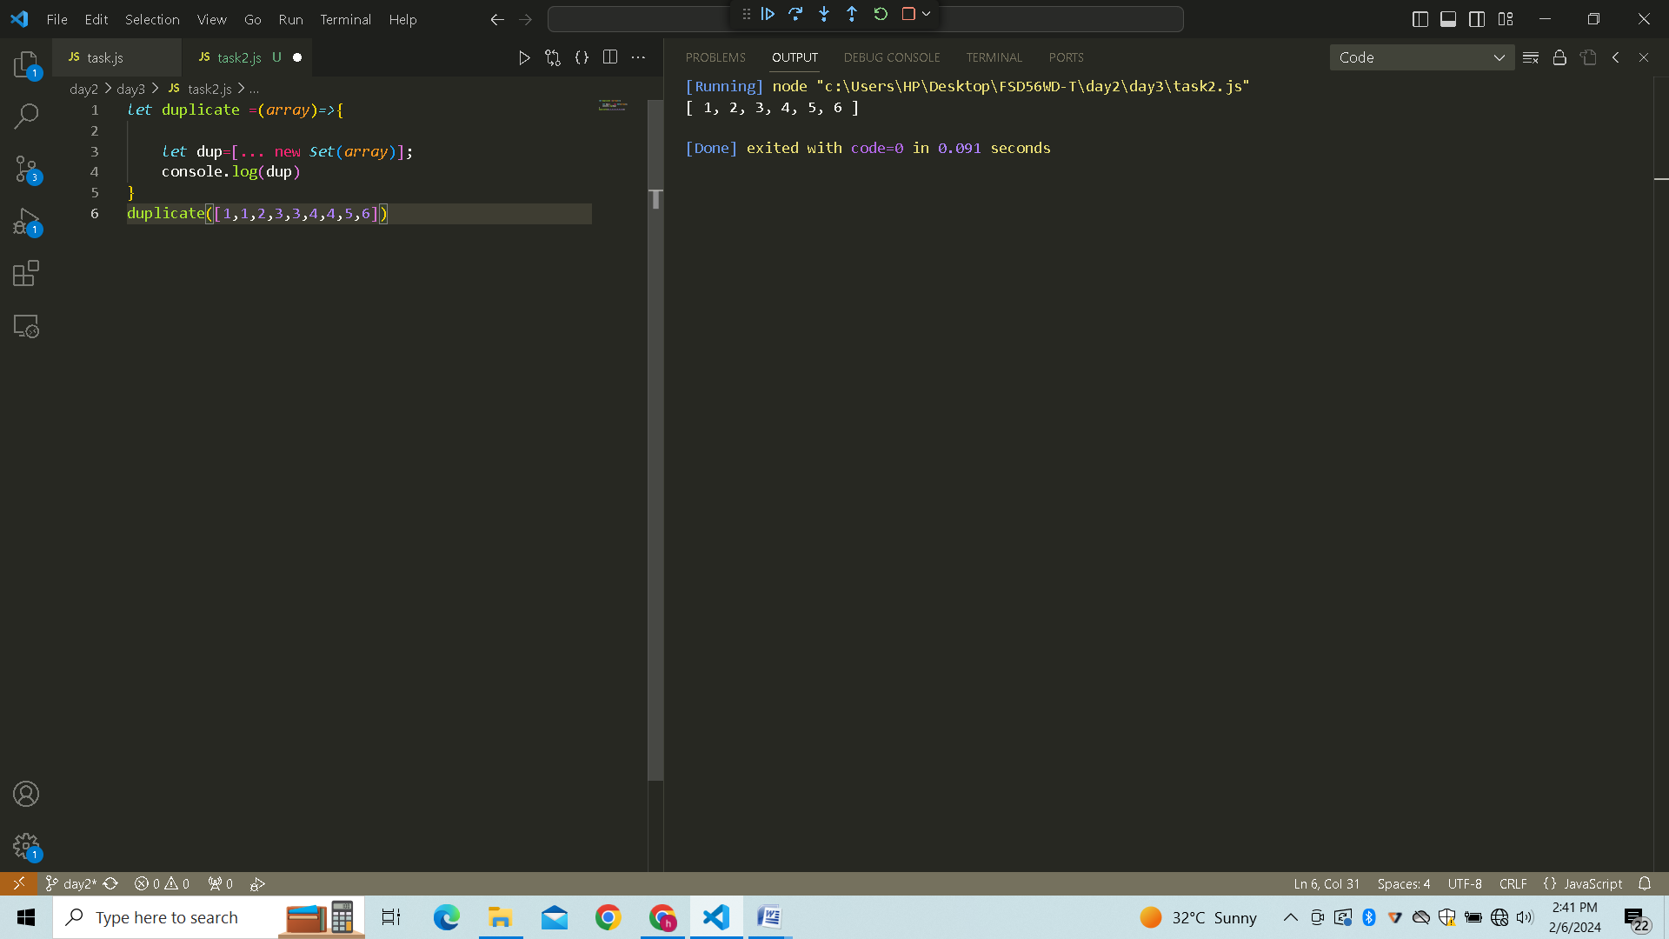

# Program 6: Rotate the array by n times…

*let* rotate = (*nums*, *k*) *=>*{

    for (*let* i = 0; i < *k*; i++) {

*nums*.unshift(*nums*.pop());

    }

    console.log(*nums*);

}

rotate([1, 2, 3, 4, 5], 2);

# Result:

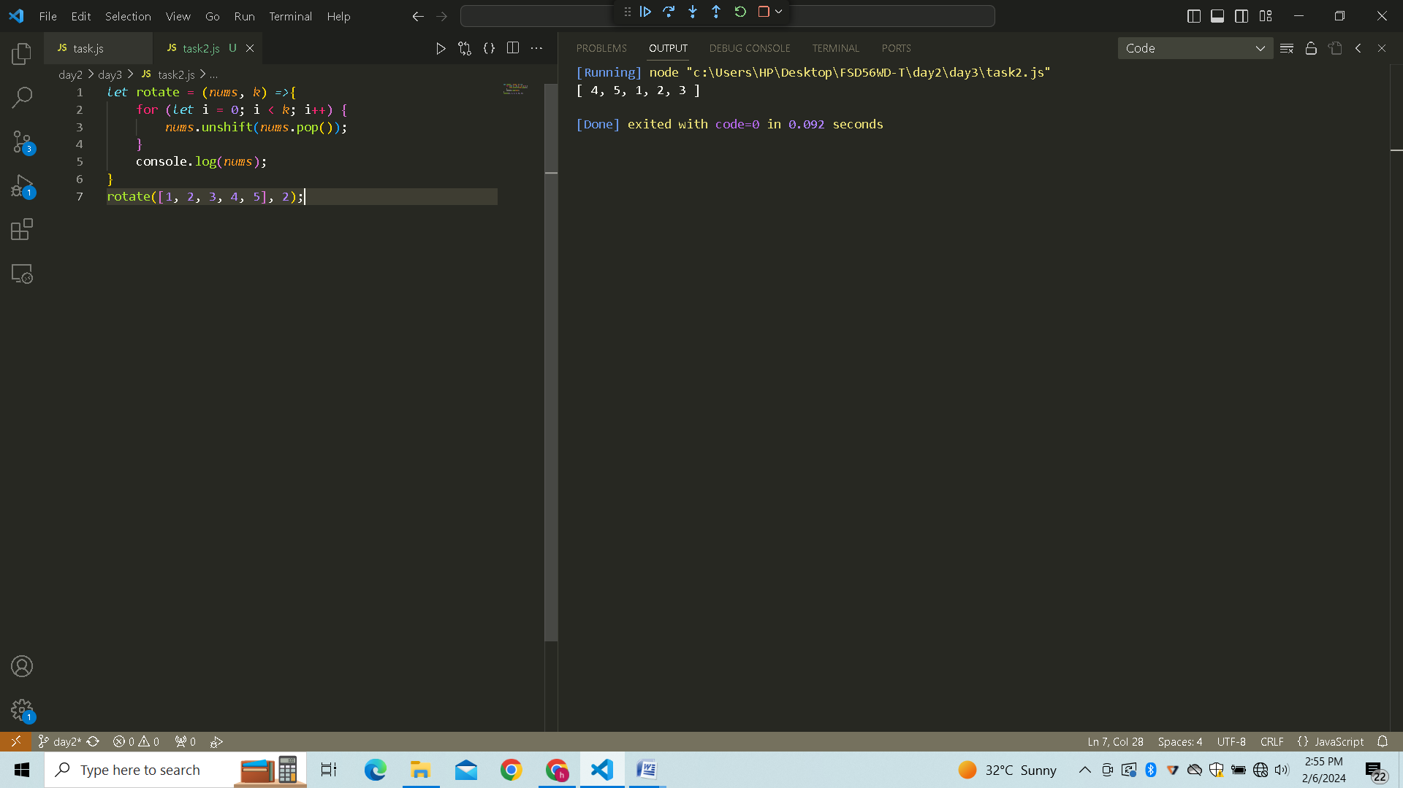

# Program 7:Return all the pallindromes in an array…

*let*  isPalindrome= (*word*)*=>*{

*let* rev =*word*.split('').reverse().join('');

    return *word* == rev;

}

*let* words=['abc','mom',"picture",'dad']

for (word of words){

    if(isPalindrome(word)){

        console.log(word);

    }

}

# Result:

